1. Provide link to GitHub repository for TAs to view the code? (1 point)

<https://github.com/HughHoang/4353Group14>

2. Discuss if your design and development methodology has changed since assignment 1 and why? (1 point)

Our design and methodology has not changed since we are currently following the design that we planned and used that to create the homepage, the sign up with text boxes, login, client profile management, fuel quote form, fuel quote history. We are still using the agile process specifically TDD which gives us the opportunity to follow our design and then clean our code with multiple test cases.

3. List what front end technologies you are using and why. List who is responsible of doing what in your group? (2 points)

Our frontend consists of Html, Javascript, and CSS. We used these three because this is what most of us are familiar with because of previous website design classes. Html is the structure and content of ourwebsite. Javascript is an external file for our function in our website, and CSS is our formatting and layout. Hugh and Julio worked on the Html code. Huan did finishing touches and some css styling

4. Provide screen shots of your front end, each page? (5 points)

home.html

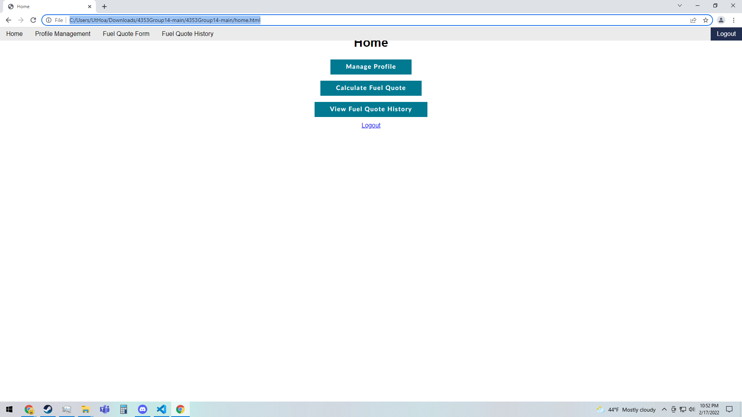

Login.html

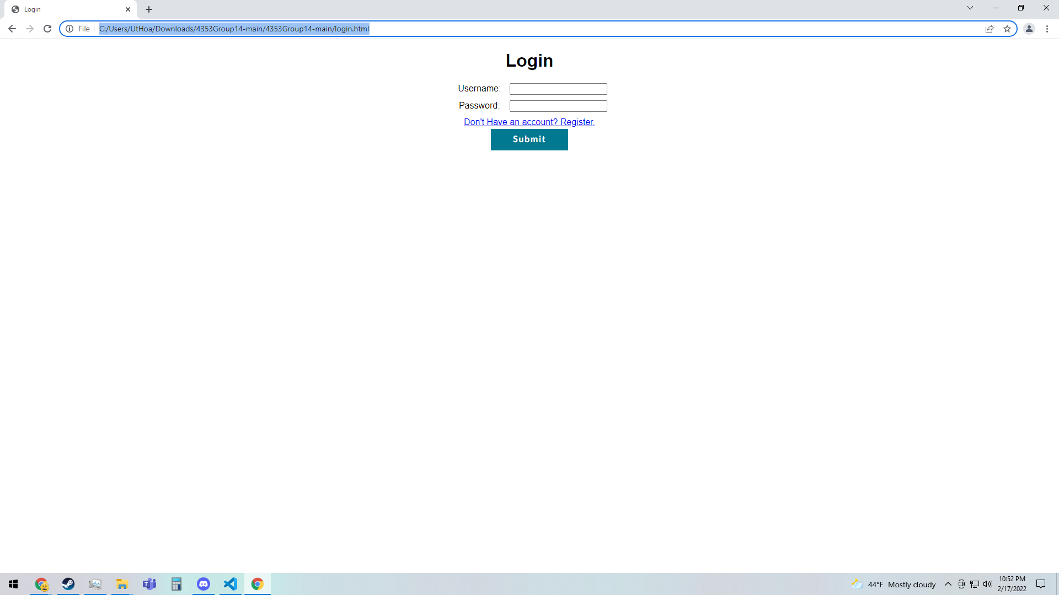

Profilemanagement.html

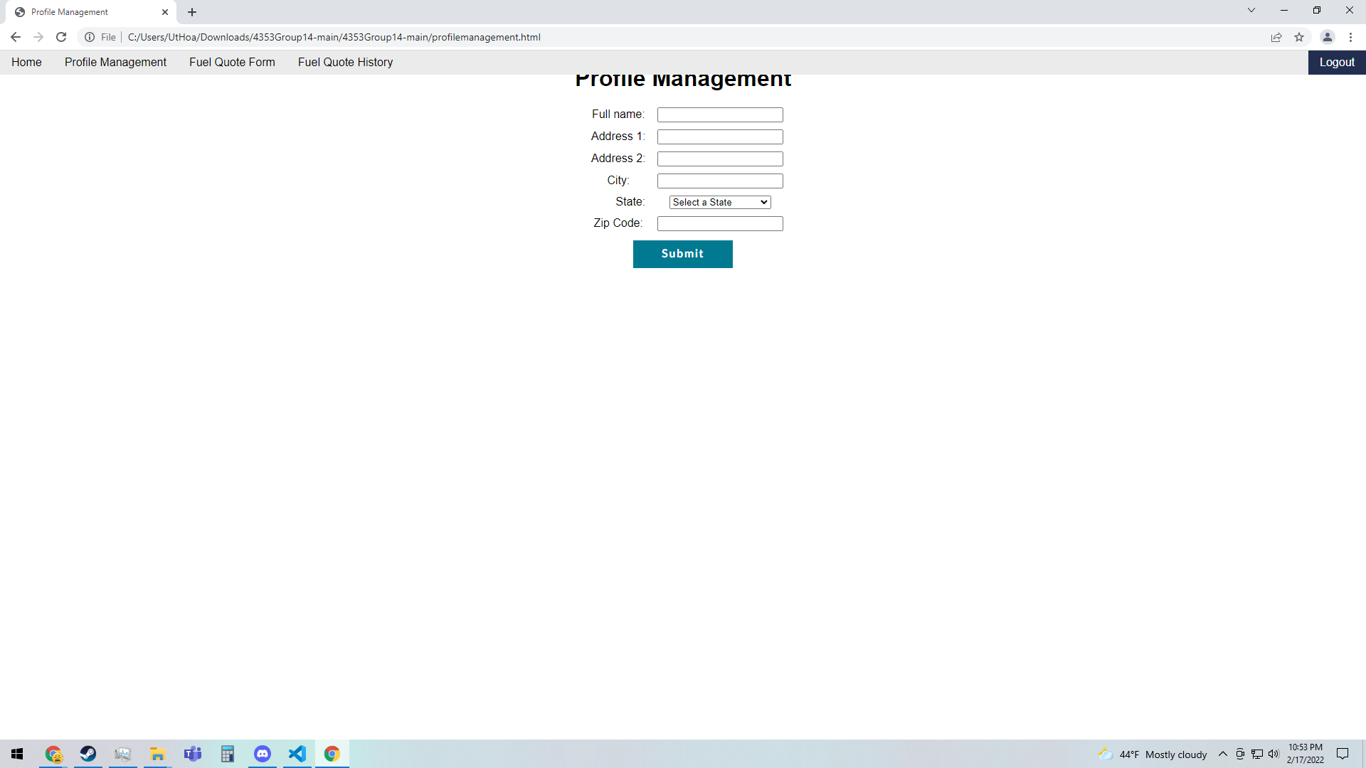

registeration.html

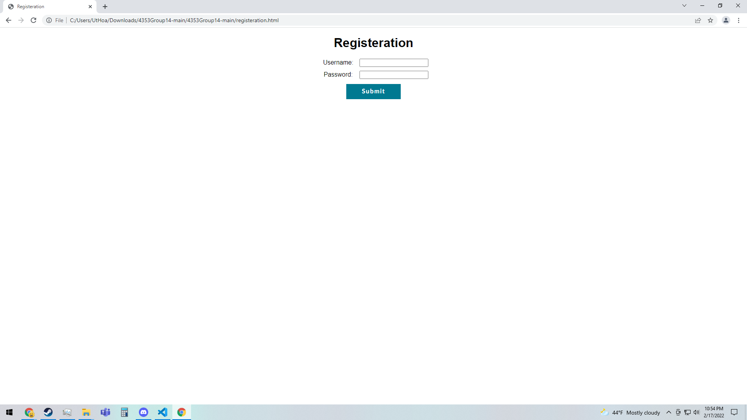

fuelquoteform.html

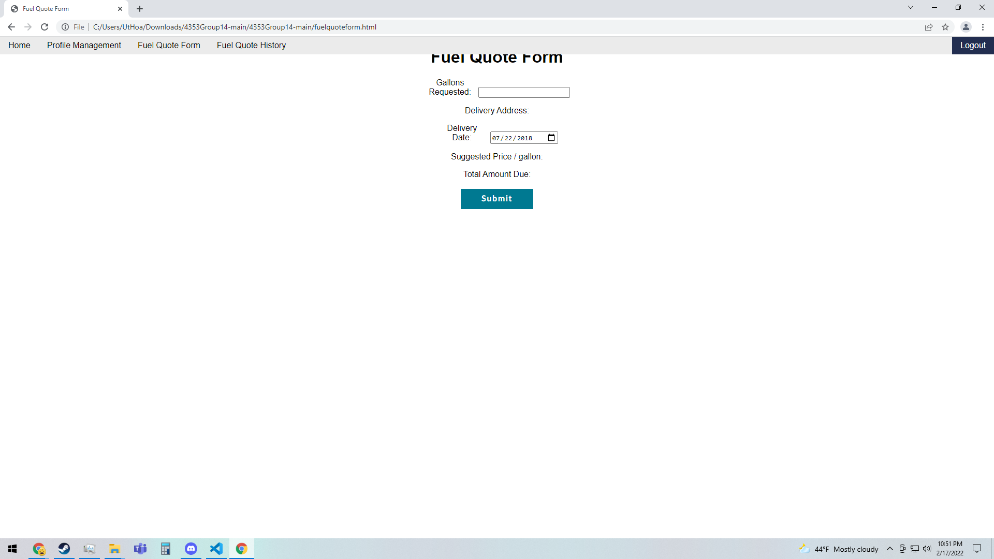

fuelquotehistory.html

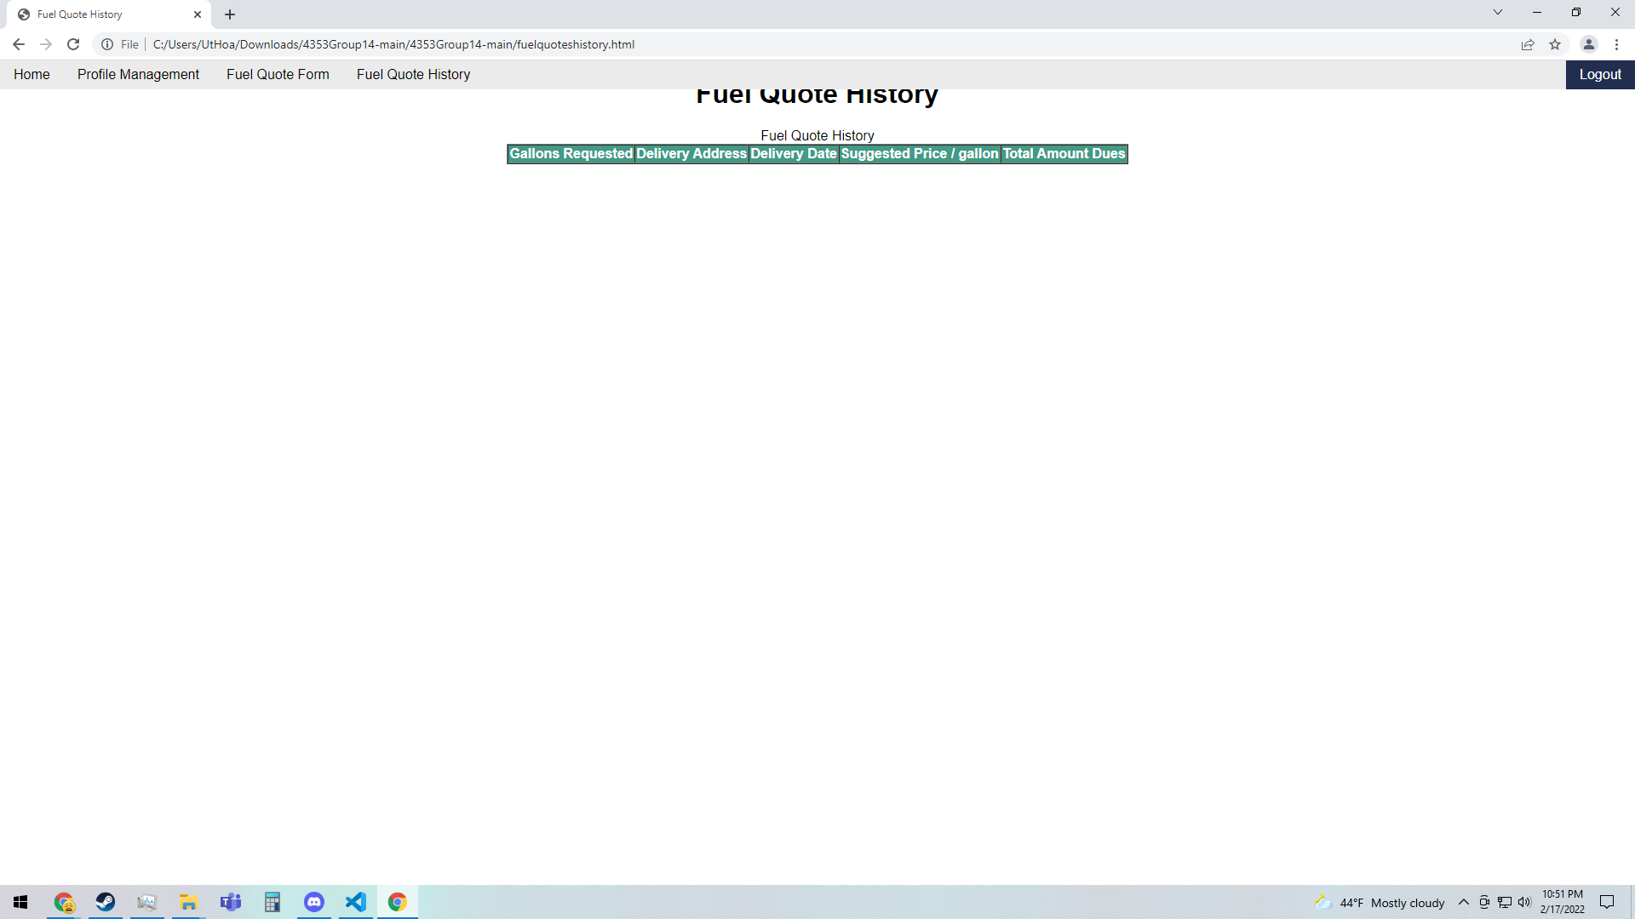

5. IMPORTANT: list who did what within the group. TAs should be able to validate in GitHub, otherwise team members who didn't contribute will receive a ZERO. (1 point)

| Group Member Name | What is your contribution? | Discussion Notes |
| --- | --- | --- |
| Hugh Hoang | Created files and filled with some html code like the inputs |  |
| Julio Santos | Collaborated and added html code |  |
| Huan Huynh | Finishing touches and creating css styling |  |